**Done by Mission Shrestha **** 2024/07/25**

**Intial Database Table Model:**  
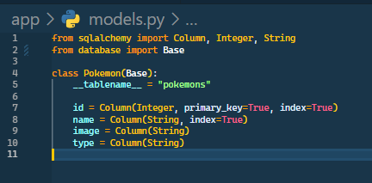

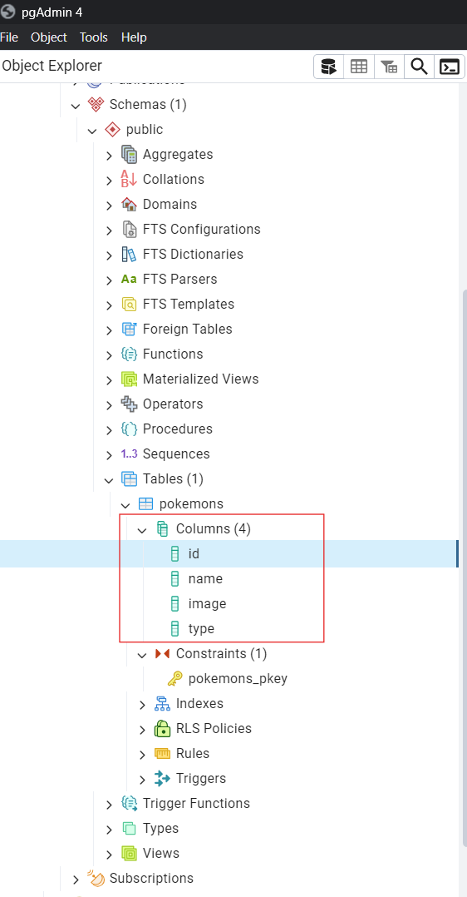

**Implementation of Fetching the data & loading into PostGre**  
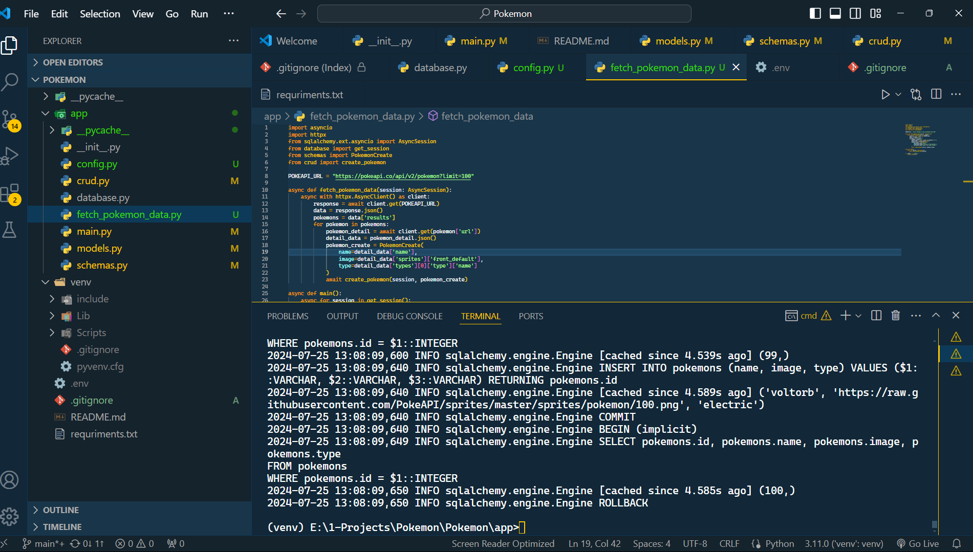

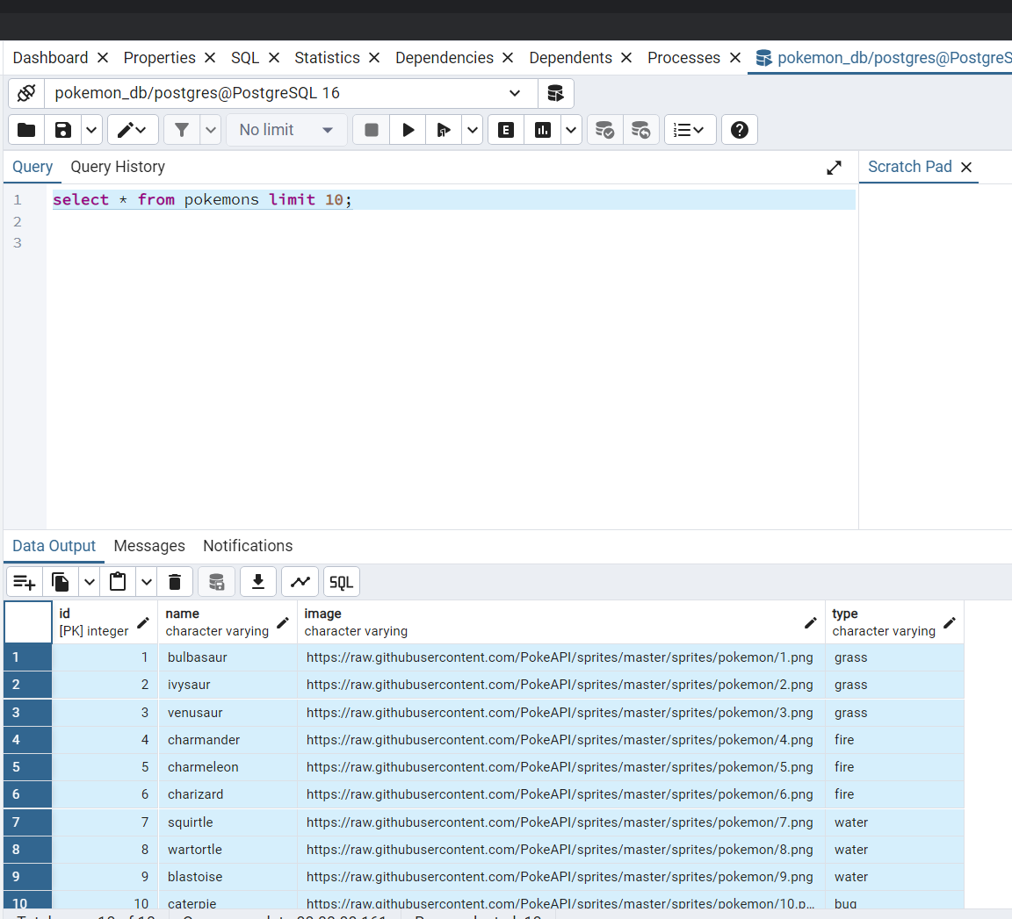

**Running the App:**

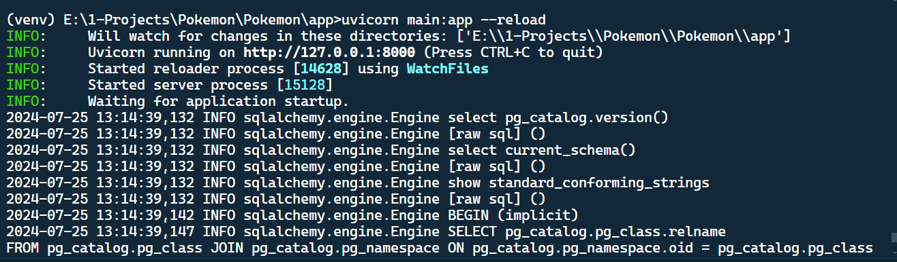

**Getting all data from the endpoint**

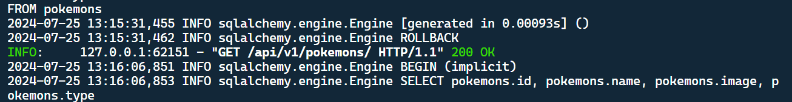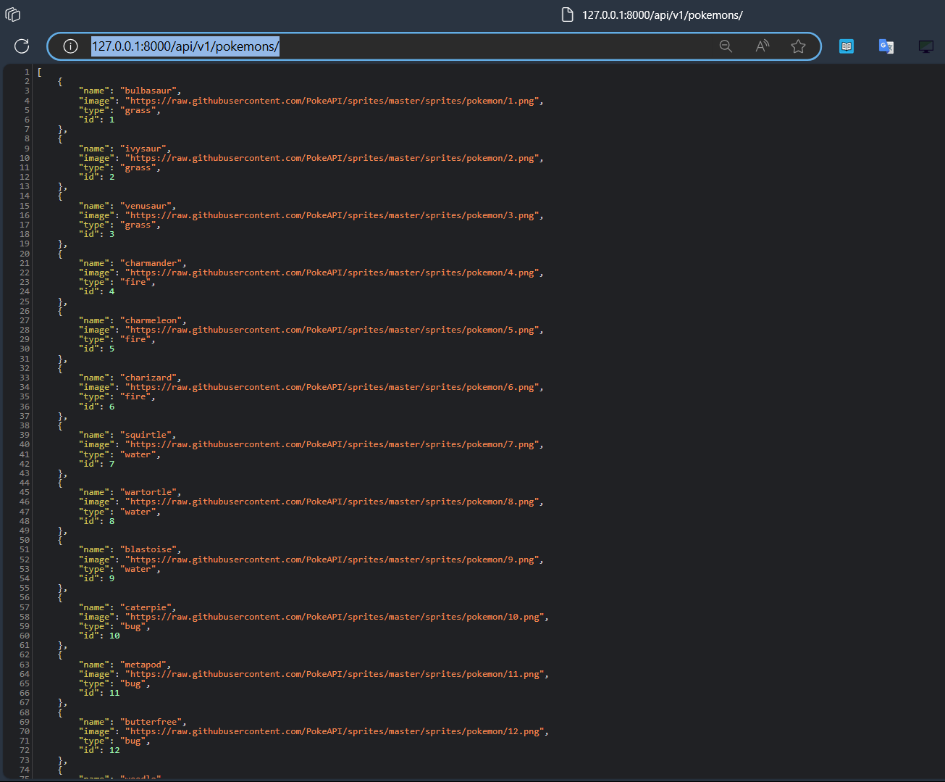

**Getting only the desired data from endpoint:**

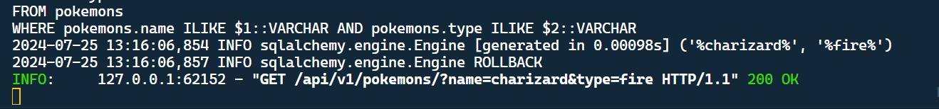

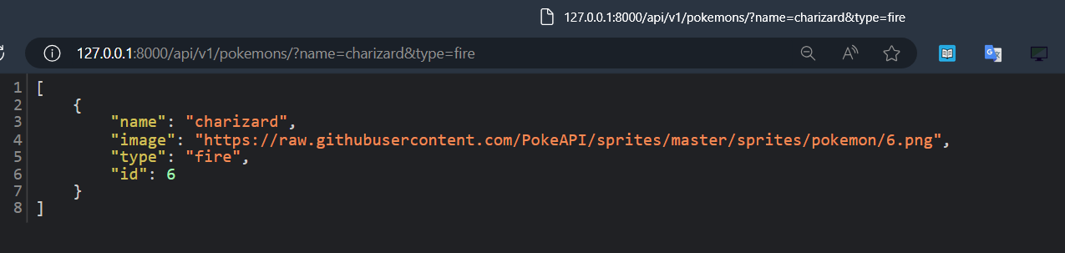

**Implementation of Type Hinting:**  
